NET481
Tutorial#3 – chapter 3+4

Q1- . In order to carry out usability tests for a new word processing package, the software has to be written and debugged. User instructions have to be available describing how the package is to be used. These have to be scrutinized in order to plan and design the tests. Subjects who will use the package in the tests will need to be selected. As part of this selection process, they will have to complete a questionnaire giving details of their past experience of, and training in, typing and using word processing packages. The subjects will carry out the required tasks using the word processing package. The tasks will be timed and any problems the subjects encounter with the package will be noted. After the test, the subjects will complete another questionnaire about what they felt about the package. All the data from the tests will be analyzed and a report containing recommendations for changes to the package will be drawn up.
Draw up a Product Breakdown Structure, a Product Flow Diagram and a preliminary activity network for the above.

The PFD of a possible solution is shown in Figure 3.1 below. Because the PFD is often the product of a subjective process, it is always worth getting the person drafting the PFD to write down a rationale for the particular sequence of activities.(You will probably have to explain what a rationale is! I have found students simply producing a textual description of what is on the PFD e.g. ‘the timetable can only be produced after the training plan has been completed’). For example, in Figure 3.1 the training plan will outline the structure of the course with rough timings for the major topics. This will have to be agreed with the client. The plan assumes that the training provider uses the design of the overheads as a preliminary step in the detailed design of the course. The overheads are then complemented by training notes and exercises. The manual brings these together into a package for the trainees. The number of trainees must be known before the material is printed so that we know how many copies to make.
There is no one right answer to this, and students might well identify gaps in the products above. For example, no training needs analysis has been produced. Hopefully, such discussions will illustrate the value of PFDs in clarifying such issues.

Figure 3.1
Training plan
User handbook
Overheads
Timetable
List of people to be trained
Course notifications
Training notes
Exercises
Training manual
Printed copies
Room bookings
Training package

Q2- How would you categorize each of the following system according to the classification in slid9(Analyze other project characteristic )
a)a payroll system .
b)a system to control a bottling plant.
c) a system which hold details of the plans of plant used by a water company to supply water to consumer.
d)a software package to support project management.
e)a system used by lawyers to access case law relating to company taxation.

Q3-Brigette at Brightmouth Collage has identified as a risk the possibility that no suitable payroll package would be available on the market. What other risks might be inherent in the Brightmouth Collage payroll project?

Q4-At what stage of a system development project ( for example, feasibility study, requirements analysis etc.) would a prototype be useful as a means of reducing the following uncertainties?
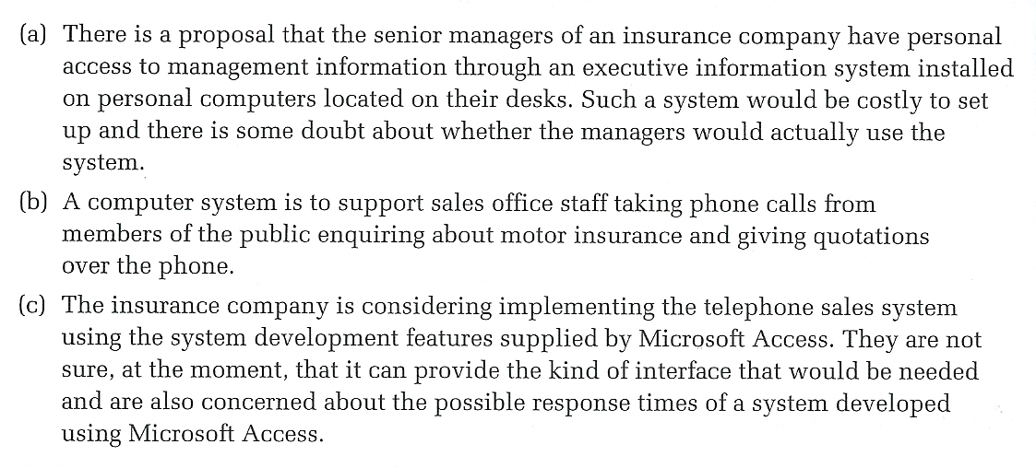

Summary table of the difference between waterfall and Agile approach
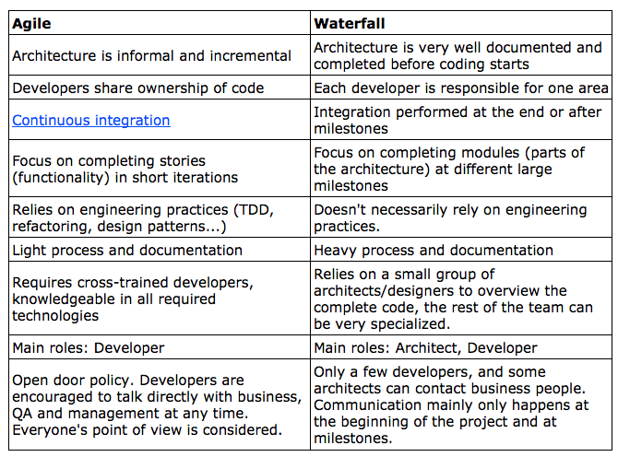
In summary, the following are the main differences in Development between Agile and Waterfall.
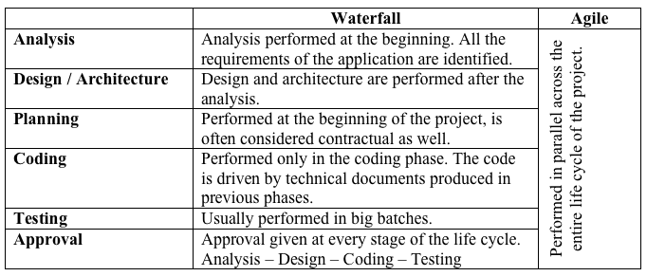
No matter if the project is considered an Agile or a Waterfall one, the main activities that are necessary to perform don’t change. What changes are “when” they are performed, and “how” they are performed. In summary there are 6 main activities in software development:

