NET481
Tutorial #5 – chapter 5 + 6( Answers)
Q1:
Given the project data below:
project | inputs | outputs | entity accesses | system users | program-ming language | developer days
1 | 210 | 420 | 40 | 10 | x | 30
2 | 469 | 1406 | 125 | 20 | x | 85
3 | 513 | 1283 | 76 | 18 | y | 108
4 | 660 | 2310 | 88 | 200 | y | 161
5 | 183 | 367 | 35 | 10 | z | 22
6 | 244 | 975 | 65 | 25 | z | 42
7 | 1600 | 3200 | 237 | 25 | y | 308
8 | 582 | 874 | 111 | 5 | z | 62
X | 180 | 350 | 40 | 20 | y
Y | 484 | 1190 | 69 | 35 | y
Note X and Y are new projects for which estimates of effort are needed.
What would be the estimated effort for projects X and Y using a Mark II function point count?

project | inputs | outputs | entity accesses | system users | program-ming language | developer days | FPs
1 | 210 | 420 | 40 | 10 | x | 30 | 297.4
2 | 469 | 1406 | 125 | 20 | x | 85 | 845
 |  |  |  | sub-totals |  | 115 | 1142.4
 |  |  |  | productivity (FPs/day) |  | 9.9
3 | 513 | 1283 | 76 | 18 | y | 108 | 757.15
4 | 660 | 2310 | 88 | 200 | y | 161 | 1129.48
7 | 1600 | 3200 | 237 | 25 | y | 308 | 2153.42
 |  |  |  | sub-totals |  | 577 | 4040.05
 |  |  |  | productivity (FPs/day) |  | 7.0
5 | 183 | 367 | 35 | 10 | z | 22 | 259.66
6 | 244 | 975 | 65 | 25 | z | 42 | 502.92
8 | 582 | 874 | 111 | 5 | z | 62 | 749.06
 |  |  |  | sub-totals |  | 126 | 1511.64
 |  |  |  | productivity (FPs/day) |  | 12.0
X | 180 | 350 | 40 | 20 | y |  | 261.8
Y | 484 | 1190 | 69 | 35 | y |  | 704.66
The above table gives the FP counts. Using the productivity rate for programming language y, the estimate for Project X would be 262/7 i.e. 37 days, and for Project Y 705/7 i.e. 101 days

Q2: Create a precedence activity network using the following details:
Calculate the earliest and latest start and end dates and the float associated with each activity.
From this identify the critical path.
Activity | Depends on | Duration  (days)
A |  | 5
B | A | 7
C | B | 6
D | A | 5
E | D | 10
F | B | 15
G | B | 8
H | G | 8
I | C | 4
J | G | 4
K | E,F | 5
L | I,H | 3

The critical path is A-B-F-K where all the floats are 0.

Q3:take another look at brigette's collage payroll activity network fragment , which related to the earlier software selection procces and which you developed in tutorial#3 .Redrow this as an activity-on-arrow network .
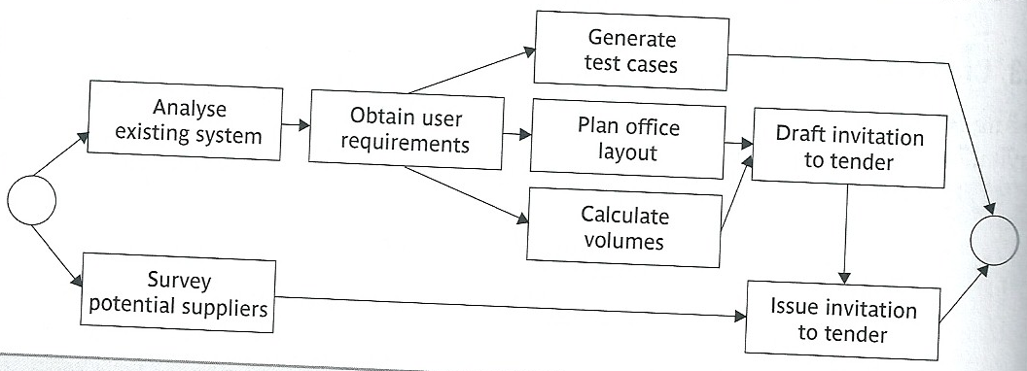

activity-on-arrow network .