NET481
Tutorial #5 – chapter 5 + 6
Q1:
Given the project data below:
project | inputs | outputs | entity accesses | system users | program-ming language | developer days
1 | 210 | 420 | 40 | 10 | x | 30
2 | 469 | 1406 | 125 | 20 | x | 85
3 | 513 | 1283 | 76 | 18 | y | 108
4 | 660 | 2310 | 88 | 200 | y | 161
5 | 183 | 367 | 35 | 10 | z | 22
6 | 244 | 975 | 65 | 25 | z | 42
7 | 1600 | 3200 | 237 | 25 | y | 308
8 | 582 | 874 | 111 | 5 | z | 62
X | 180 | 350 | 40 | 20 | y
Y | 484 | 1190 | 69 | 35 | y
Note X and Y are new projects for which estimates of effort are needed.
What would be the estimated effort for projects X and Y using a Mark II function point count?

project | inputs | outputs | entity accesses | system users | program-ming language | developer days | FPs
1 | 210 | 420 | 40 | 10 | x | 30
2 | 469 | 1406 | 125 | 20 | x | 85
 |  |  |  | sub-totals
 |  |  |  | productivity (FPs/day)
3 | 513 | 1283 | 76 | 18 | y | 108
4 | 660 | 2310 | 88 | 200 | y | 161
7 | 1600 | 3200 | 237 | 25 | y | 308
 |  |  |  | sub-totals |  | 577
 |  |  |  | productivity (FPs/day)
5 | 183 | 367 | 35 | 10 | z | 22
6 | 244 | 975 | 65 | 25 | z | 42
8 | 582 | 874 | 111 | 5 | z | 62
 |  |  |  | sub-totals |  | 126
 |  |  |  | productivity (FPs/day)
X | 180 | 350 | 40 | 20 | y
Y | 484 | 1190 | 69 | 35 | y

Q2:
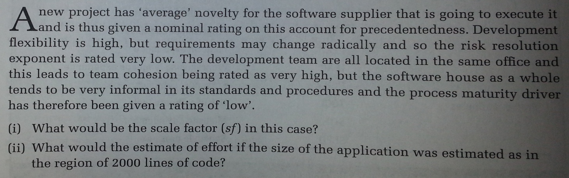

Q3: Create a precedence activity network using the following details:
Calculate the earliest and latest start and end dates and the float associated with each activity.
From this identify the critical path.
Activity | Depends on | Duration  (days)
A |  | 5
B | A | 7
C | B | 6
D | A | 5
E | D | 10
F | B | 15
G | B | 8
H | G | 8
I | C | 4
J | G | 4
K | E,F | 5
L | I,H | 3

Q4:take another look at brigette's collage payroll activity network fragment , which related to the earlier software selection procces and which you developed in tutorial#3 .Redrow this as an activity-on-arrow network .
